**Dynamic Web Applications Documentation by Vlad Rotari 33830924**

**Outline**

LevelUp- Health Quests is a web application designed to turn everyday workouts into short quests that users can complete and log, through a gamified process. Finding the right workout plans is usually difficult, and the app tries to offer a better solution by providing quests such as **Abs of Steel** or **Medium Jogging Quest**, each with it’s own difficulty level, target duration and a list of exercises to do.

Users are able to register, log in, browse quests, and even view quest details and record completions, which are stored as personal logs under their separate tab. A dashboard highlights a daily quest and basic statistics like total quests, core quests and outdoor quests to give a quick sense of available content for that day. The app also includes a weather checker that uses the OpenWeather API to advise whether it is a good idea to attempt outdoor jogging quests. The user is able to check the weather separately as well but its meant to be used as a helping tool inside the app.

The system is built with **Node.js**, **Express**, **MySQL**, **EJS** templates and features a custom CSS. The project demonstrates a secure login feature with bcrypt, structured data storage for quests and logs, session-based authentication, and safe integration with an external API, all deployed behind Apache under a /usr/ prefix on the Goldsmith’s Virtual machines.

**Architecture**

**High-level architecture**

The application tier features a Node.js/Express server which lives under index.js that mounts modular routers and renders EJS templates into HTML. Static assets such as public/style.css are served by Express. Configuration like database credentials, session secret, OpenWeather API key, and APP_BASE_PATH for the VM is handled via environment variables (dotenv). The data tier uses MySQL and its being accessed using mysql2 with parameterised queries.

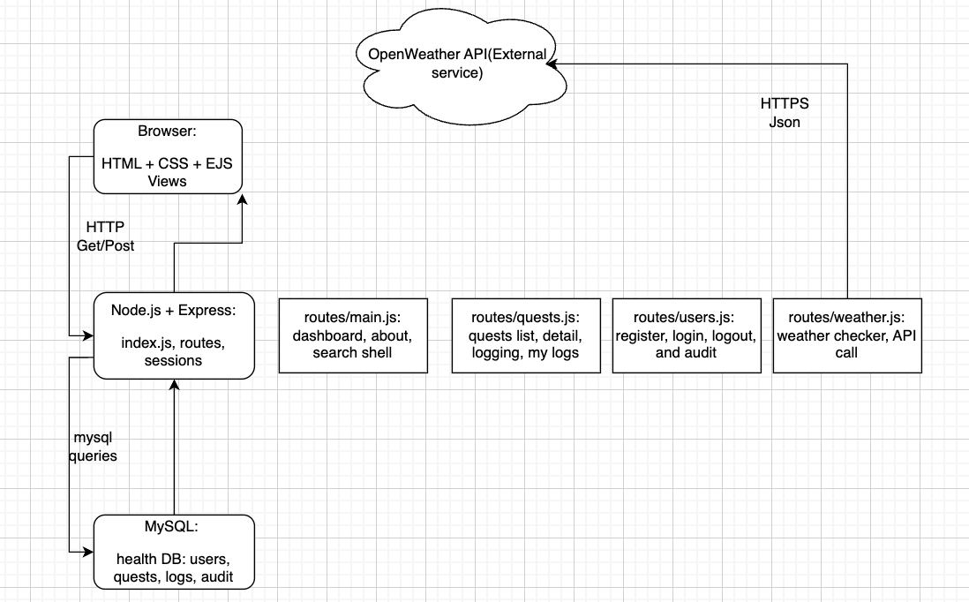

**Data Model**

**Core entities**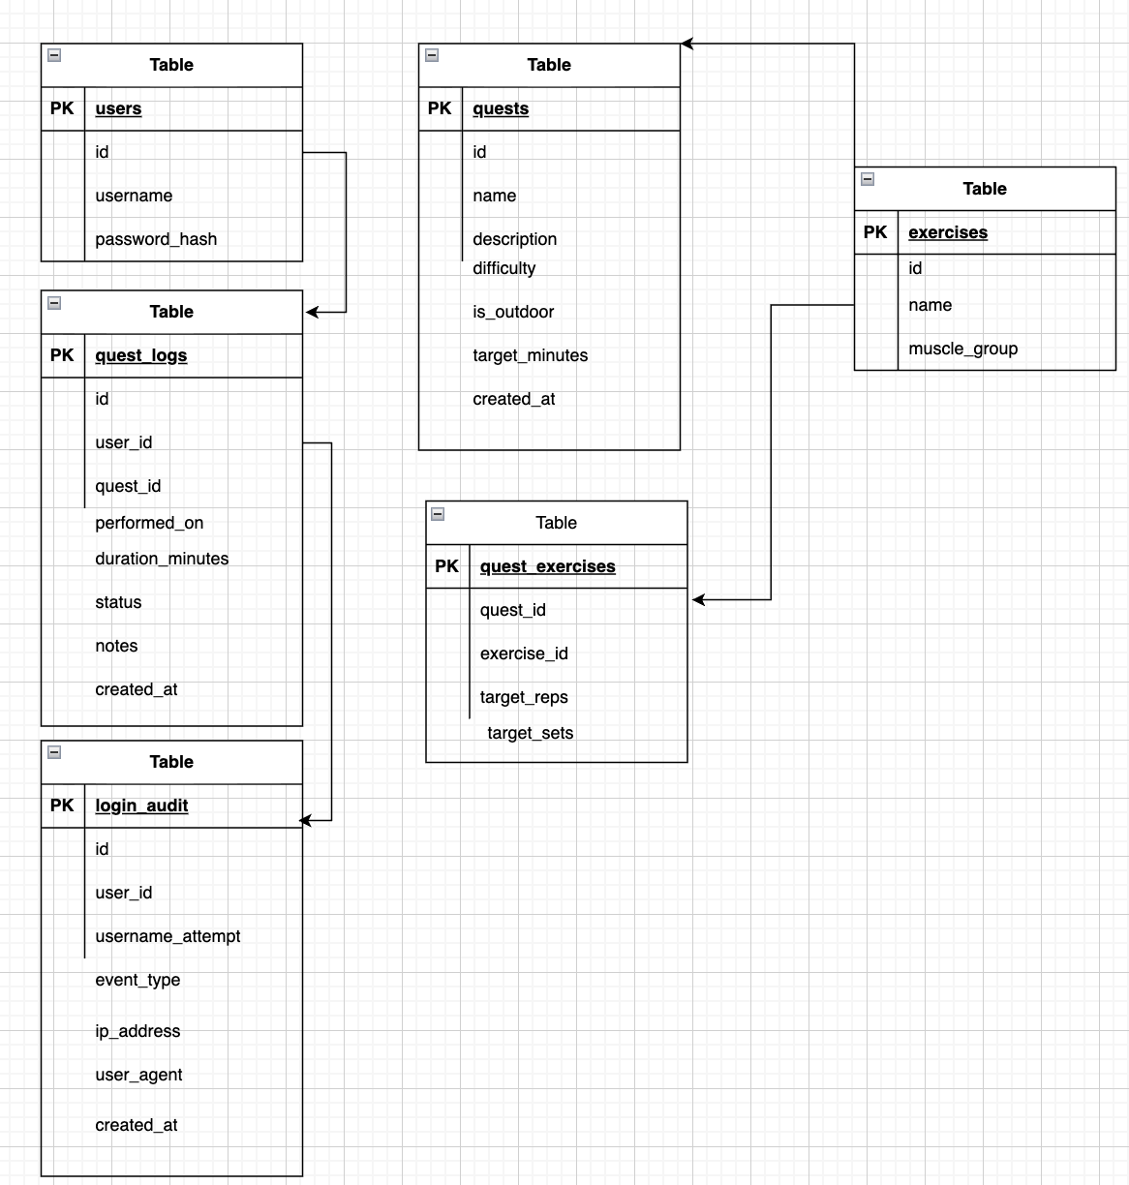

**User Functionality**

**Dashboard (/)**

The dashboard element of the web app presents a “Daily Quest” card. This greets the user with a nice dashboard interface showcasing a quests name, description, difficulty and target minutes. Below that, it displays instances of all quests, core-focused quests and outdoor quests, all fetched from MySQL via routes/main.js. The app also features a right-hand sidebar which offers quick links to the weather module and quest library. The navigation bar is consistent across pages and adapts to login status showing greeting, “My logs”, “Audit” for gold, and Logout when authenticated.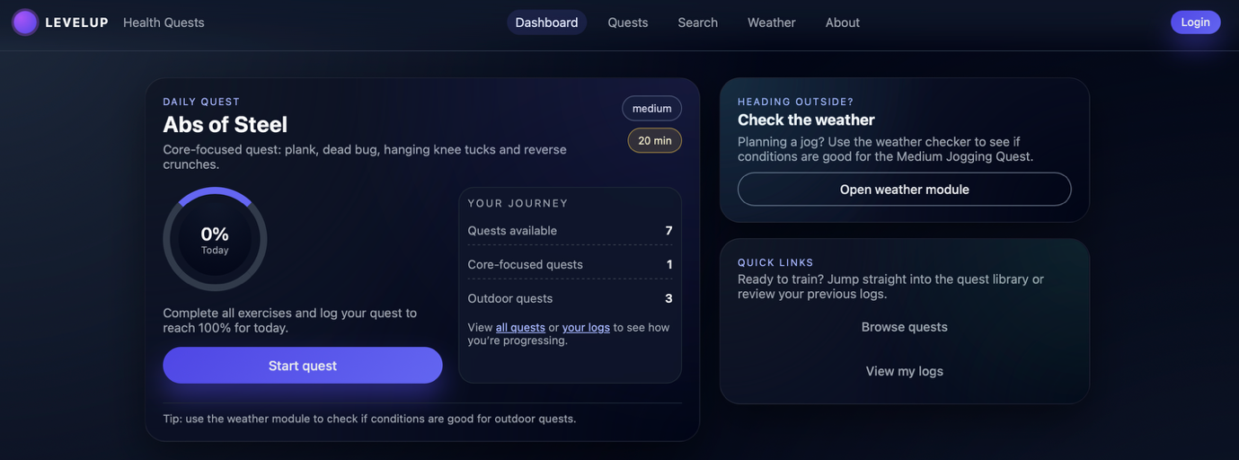

*Screenshot: Dashboard showcasing daily quest card, stats and top navigation.*

**Accounts and user authentication**

At /users/register, users are able to create an account with validation for username length, password length and password confirmation. On /users/login, credentials are checked using bcrypt. When login succeeds, the user’s id and username are stored in the session. A redirectLogin middleware in routes/users.js and routes/quests.js protects routes such as **Log completion**, **My logs**, and **Audit**, ensuring only logged-in users (and only gold as the admin for the audit page) can access them.

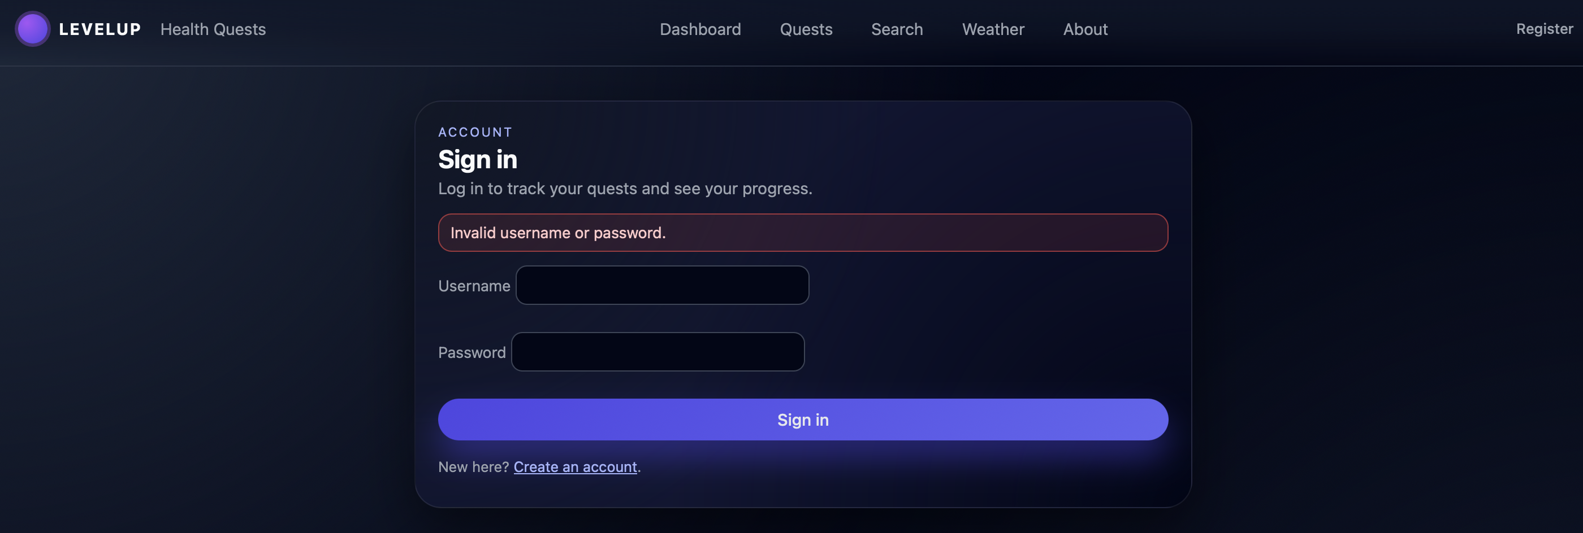

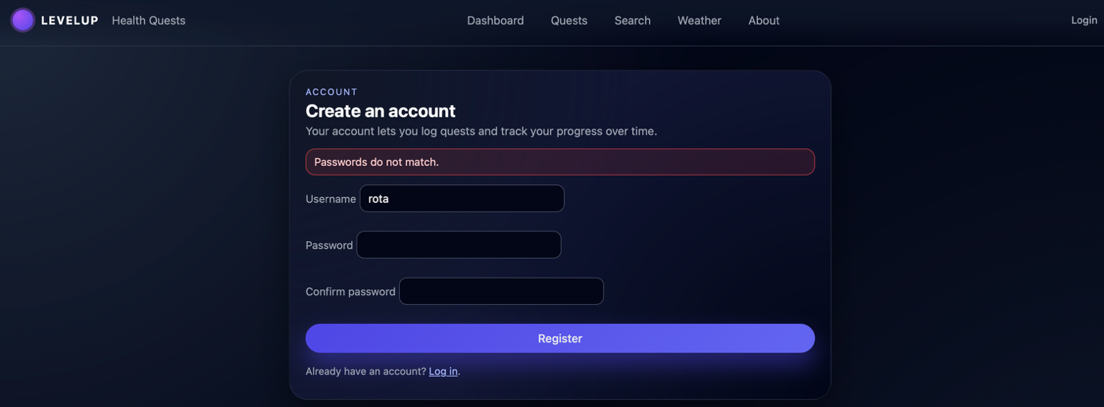

*Screenshot: The Login and registration forms with an error message examples for sanity checks.*

**Quest library, search and quest detail**

The quest library at /quests lists all quests in a table. Users can filter these by:

* Searching a term like the quest’s name,
* Difficulty (easy/medium/hard),
* Outdoor-only checkbox.

These filters are applied in routes/quests.js using parameterised SELECT queries with optional WHERE clauses. Clicking upon a quest name opens /quests/:id, which displays the full details and associated exercises fetched via a join on quest_exercises and exercises. Outdoor quests include a prompt to check the weather first. The /search page is a simplified front-end that submits filters to /quests.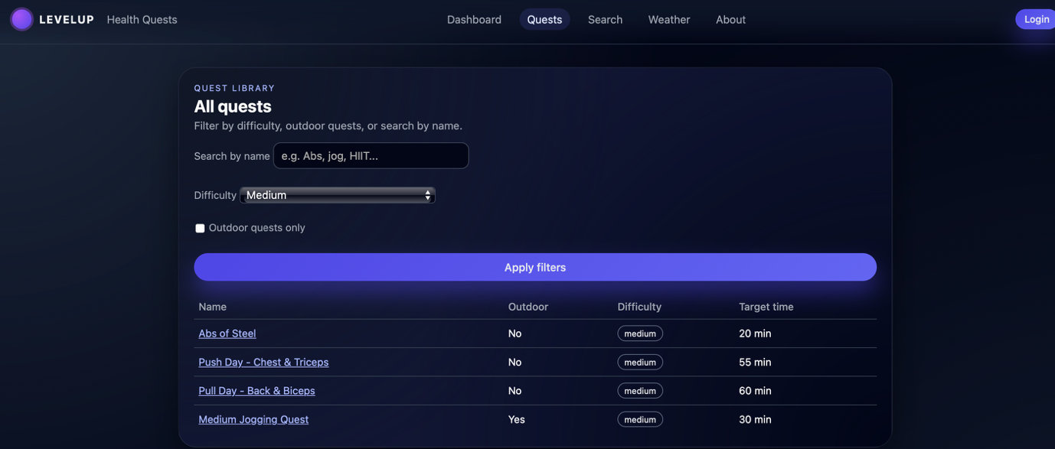

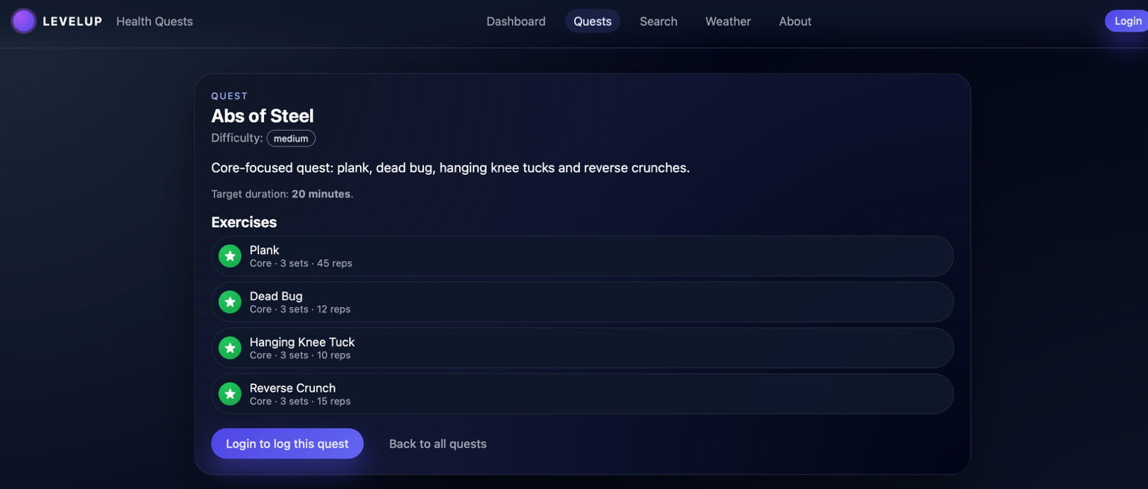

*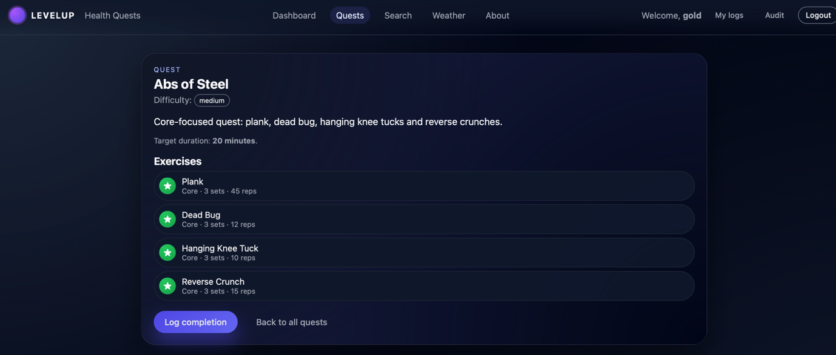Screenshot: Quests page with a filter applied and its form and results table.*

*Screenshot: Quest detail page with exercises list and “Log completion” button, while logged in and one without.*

**Logging completions and viewing history**

In order to see the logs the app opens from a quest detail page, the **Log completion** button which opens exactly quests/:id/log. This form allows the user to select the date, a duration in minutes, a status like completed/failed/abandoned, and free-text notes in order to log a quests done for that day and anything else they might’ve experience then. On submit, the routes/quests.js inserts a new row into quest_logs for the current user_id and quest_id, and then redirects back to the quest details.

The **My logs** page at /quests/me/logs shows a joined view of each user’s quest_logs with quest metadata (name, difficulty, outdoor flag). This gives a simple history of training sessions and outcomes.

*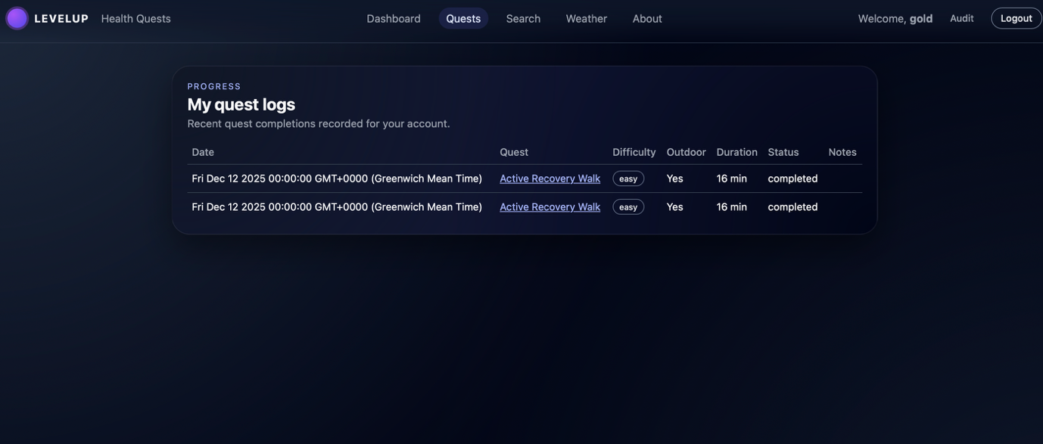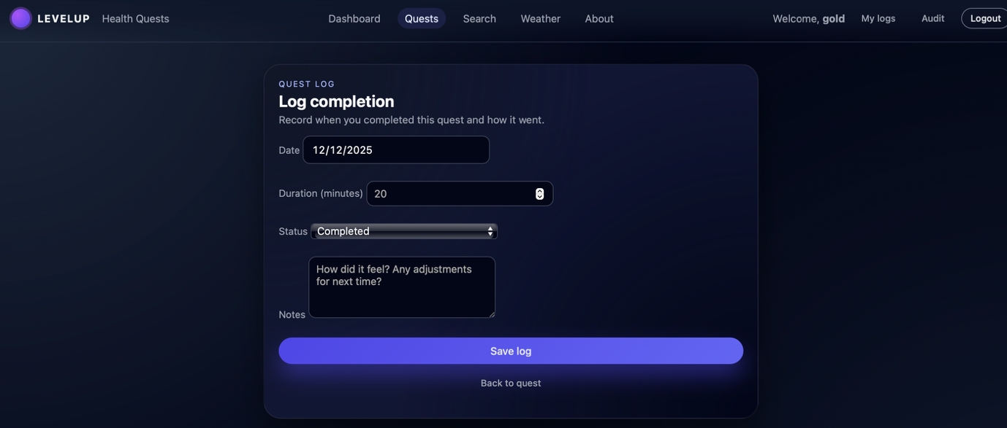Screenshot: Log completion form.*

*Screenshot: My logs page showing recent quest logs.*

**Weather module**

The weather page at /weather lets users enter any city they would like. Then the server sanitises the input, calls the OpenWeather API using the configured API key, parses the JSON and displays a summary including: temperature, feels-like temperature, wind and humidity. Basic logic behind it classifies the conditions as too cold/hot, storming, raining and then it generates a friendly running recommendation, for example suggesting indoor training or encouraging an outdoor jog. I’ve coded one example in which if “Medium Jogging Quest” exists in quests, the page links directly to it.

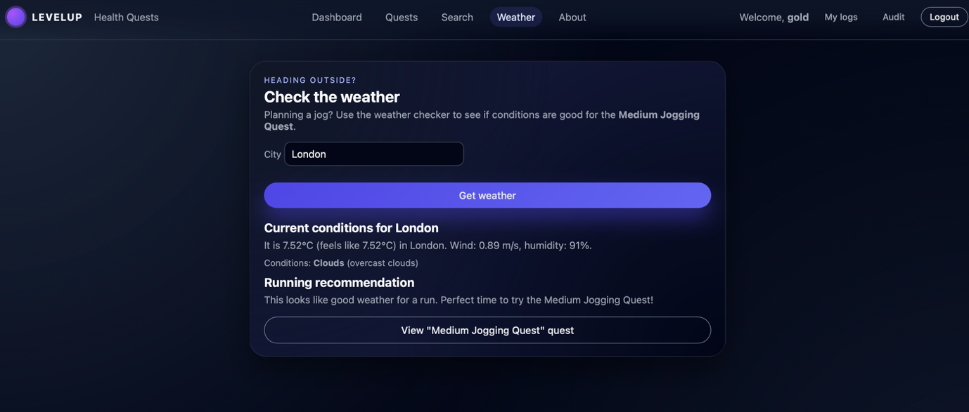

*Screenshot: Weather page with current conditions and jogging recommendation.*

**About and audit**

The About page (/about) explains the purpose of the LevelUp- Health application and its tech stack. The audit page (/users/audit), is restricted only to the gold user or an admin if you will, and it lists recent login events from login_audit so people with admin priviledges can see the security behind logging in.

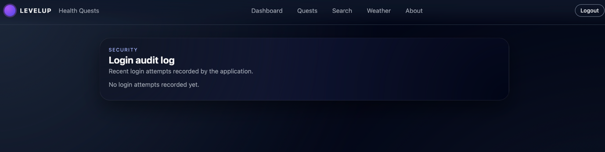

*Screenshot: About page and Audit table.*

**Advanced Techniques**

**1. Secure password handling with bcrypt and sessions**

User passwords are never stored in plaintext. In routes/users.js, registration hashes all passwords with bcrypt:

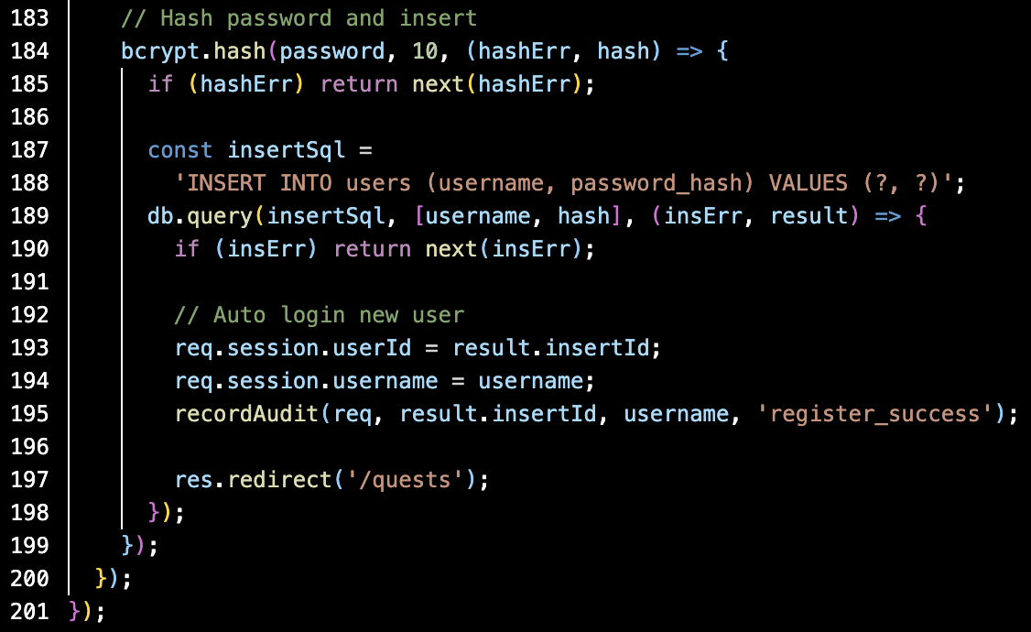

Login part then compares the supplied password with the stored hash and sets session variables:

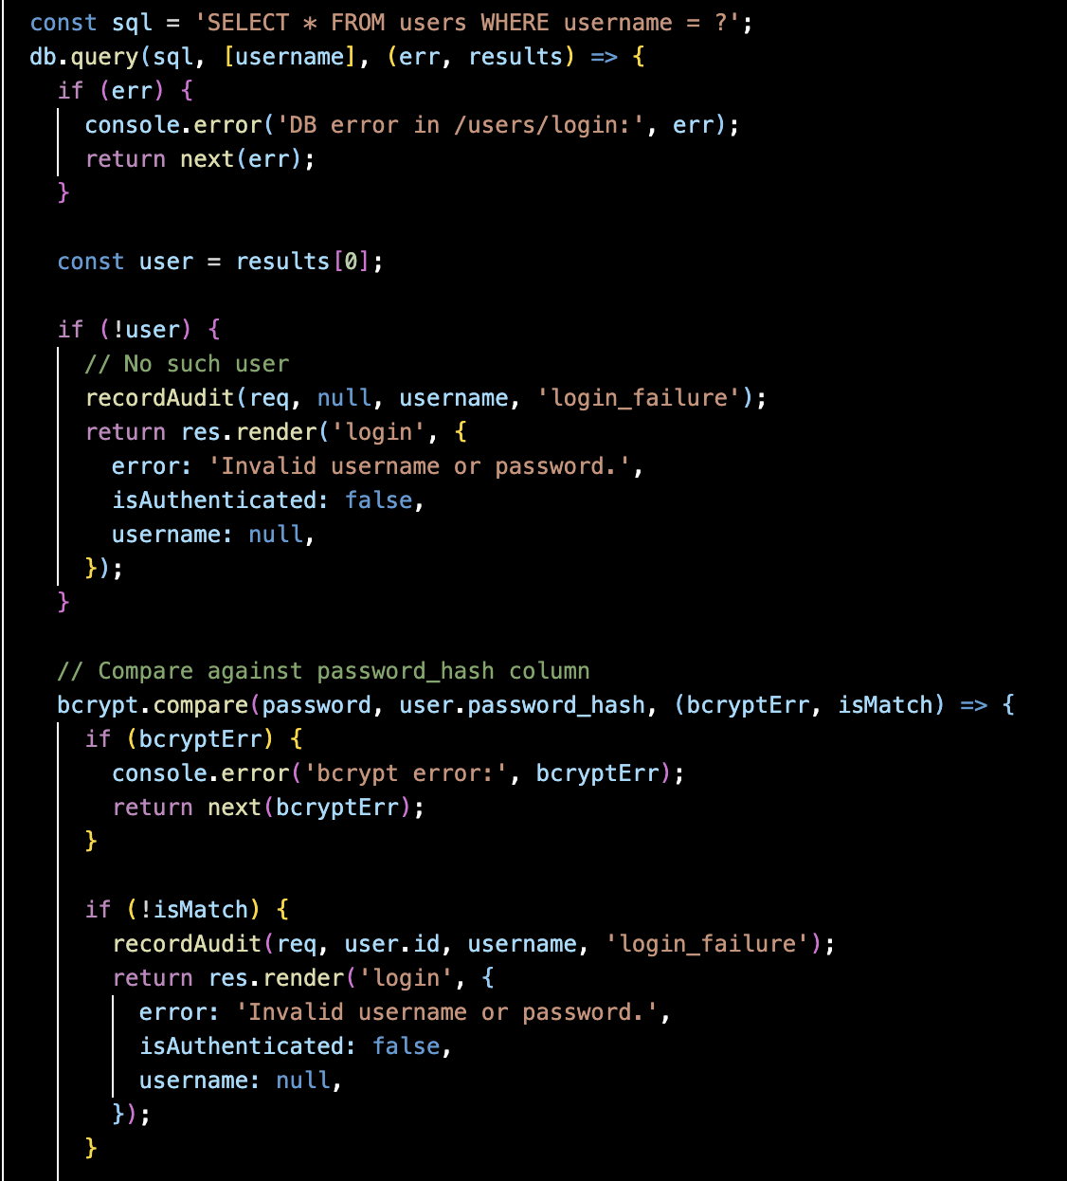

**2. Robust login audit logging**

Every time someone logs in successfully, every time someone fails and logs out is logged in login_audit with timestamp, IP and user agent. A helper function in routes/users.js centralises this: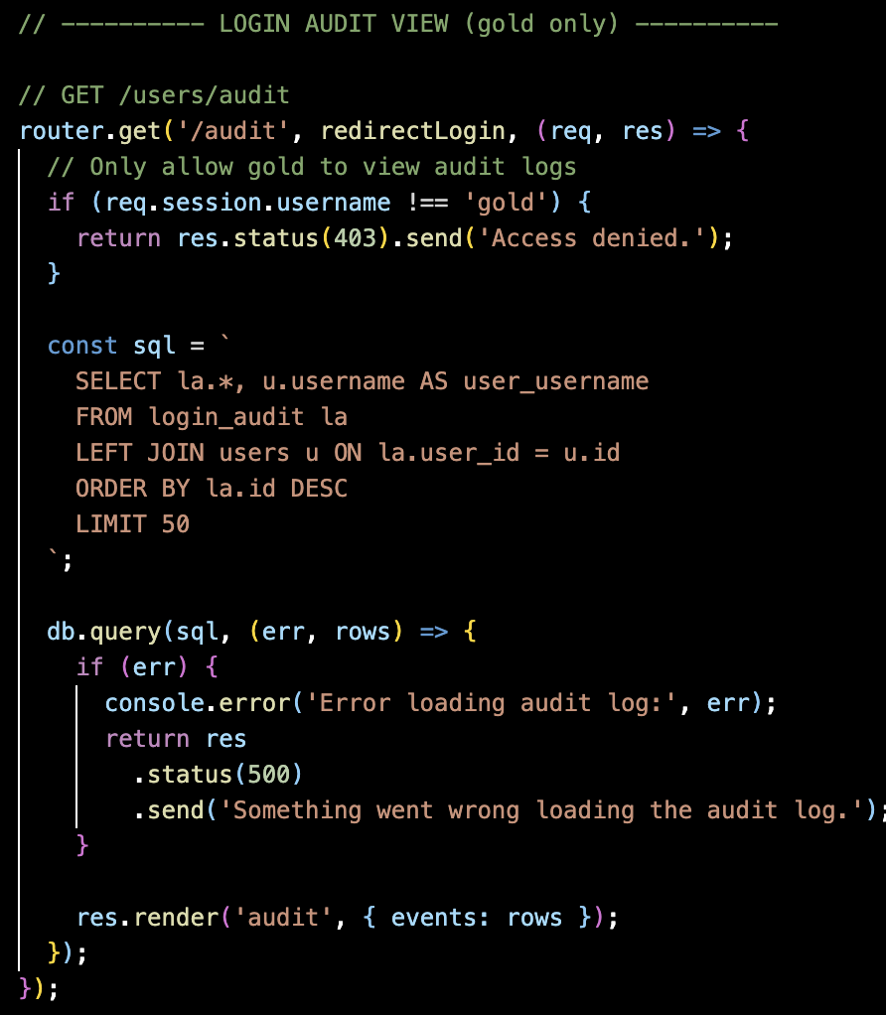

**3. External API integration and input sanitisation**

The weather route demonstrates server-side HTTP integration and safe handling of user input, see below:

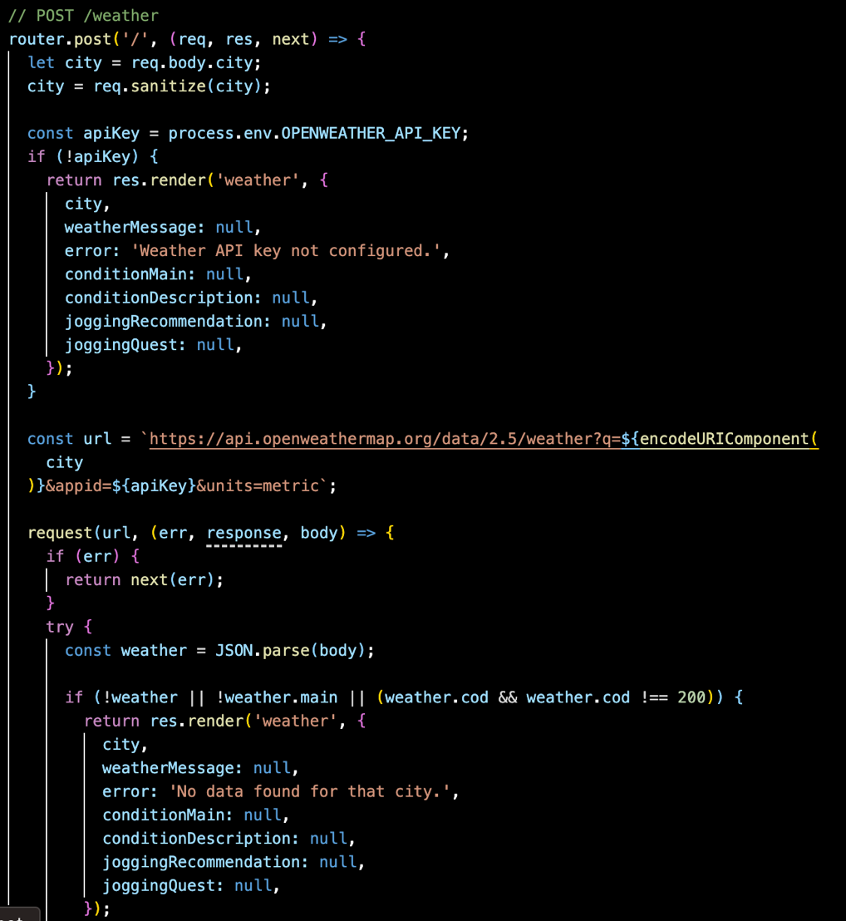

Using req.sanitize, encodeURIComponent and environment variables demonstrates awareness of injection risks and attacks as well as configuration management.

**AI Declaration**

I used AI ChatGPT as a supporting tool during this assignment in the following ways:

* **Design and planning:** it helped me refine the concept of the LevelUp app, decide on the main features such as quests, quest logs, weather module, daily quest feature.
* **Debugging and refactoring:** to diagnose and fix issues such as broken EJS paths, base-path problems on the VM, and missing template variables. I asked for explanations of error messages and then applied and tested the suggested fixes afterwards. You could say it was considered as a part time tutor.
* **Documentation:** I’ve utilised Ai here to produce the best documentation template for an application like this.

Any content that was Ai generated was adapted, reviewed and integrated by myself. The final decisions regarding the web app, the debugging or testing process was all my doing. Finally the application runs on the Goldsmiths Virtual Server machine.